SDC200 Meeting
Wednesday, March 27, 2024
12 PM Pacific

Attendance:
Sharla Riead
Doug McCleery
Robert Lipkins
Chris Urbanus
Eurihea Speciale
Scott Doyle
Mark Schroer
Christine Do

Meeting Notes:
Meeting started at 12:04 PM Pacific.

Sharla provided the group on context around the Interpretation Request and Eurihea gave insight into previous discussions about evaluations being proctored remotely. He also noted that the HERS Modeler examination was not considered at the time that the language was created, and that the IR presents an opportunity to address that too.

Doug also discussed the intent of proctoring. Unlike a field exam, the simulated exams and multi-choice exams do not require technical expertise but rather ensuring the integrity of the environment.

Eurihea gave some insight into his providership’s experience training in a remote environment and the consequences of those who never formally got field training until recently. Overall, the group agreed that there are a lot of hands-on components that need to be addressed throughout this process that a remote/virtual procedure cannot replicate.

In addressing the interpretation request, the group answers “No”.
The reasoning was the following:

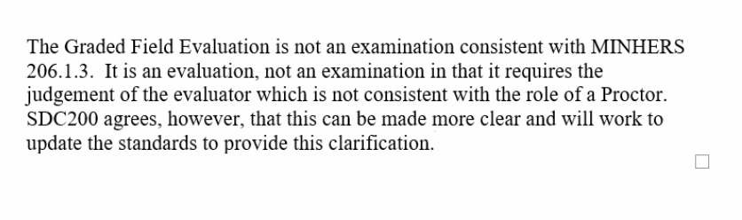

The group then considered the language in Section 206. After discussing, Sharla will reach out to Rick to request a NWI from the SMB. Another meeting will be scheduled afterwards.

Meeting ended at 12:37 PM Pacific.

