**RESNET 1550 Technical Working Group**

**Meeting Minutes**

**March 25, 2025**

[MEETING RECORDING](https://zoom.us/rec/share/MZePXagiGx83UUkt0fx3F0lytS_nFw8AVloYg6urSVZMTmLG6vhCNe4teG7Fs98W._zvIivbtLa_96UJ_)

Passcode: Y5!$rd4q

|  |  |
| --- | --- |
| Present | RESNET Staff |
| Chris Magwood  Megan Cordes  Philip Squires  Yatharth Vaishnani  Karla Butterfield  Brian Shanks  Ariel Brenner  Matthew Cooper  Jacob Racusin  Ari Rapport  Don Davis  Nigel Watts  Andy Buccino  Tracy Huynh  Mike Browne  Erin Bordelon | Noah Kibbe  Katie Stewart |

[Link to Comments](https://www.dropbox.com/scl/fi/q3hav075rr9lqavu8v7zt/250306_1550-Comments_PDS01.xlsx?rlkey=qsse0tkxemk66xzfqyqlpixze&e=2&st=0he7g79s&dl=0)

[Link to Draft Standard PDS-01](https://www.dropbox.com/scl/fi/4ine3cvrj4hs91lh8v8t2/250306_PDS02-RESNET-C1550.docx?rlkey=ldaow0956tyw1qiflzc69ewco&e=2&st=bldtfv8p&dl=0)

Meeting began at 12:33 PM ET.

1. Weekly meeting cadence/protocol
   1. In advance of meeting, please review the comments under consideration for the meeting and leave notes in Column J if you have discussion points
   2. If you are not able to attend but want to provide input on a particular comment, let us know
   3. To edit the spreadsheet, you must open in Excel using the menu on the top left of the Dropbox spreadsheet:  
      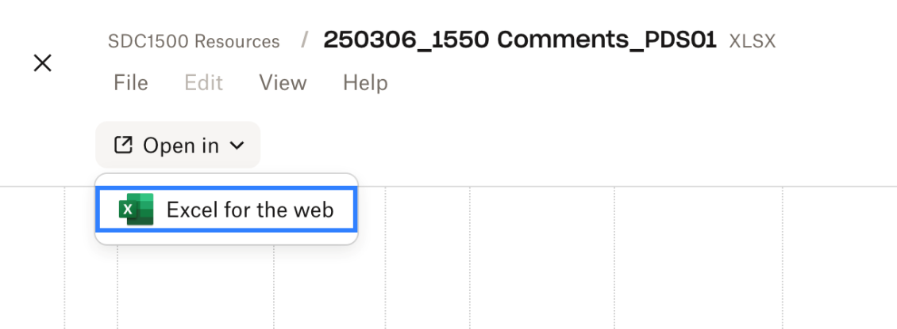
   4. For technical assistance, please contact [admin@resnet.us](mailto:admin@resnet.us).
2. Draft responses for rejections will be on the spreadsheet starting next week.
   1. The Task Force won’t review during meetings, asked that attendees/volunteers leave comments if you have suggestions or concerns.
   2. The Task Force will vote as a group on all responses at the end of the process prior to sending them to the SDC.
3. The Task Force will select a range of comments to address in advance for each meeting, allowing members to prepare.
   1. This week, the Task Force will focus on moving through all of the acceptances.
4. Next week, the Task Force will focus on "accept in principle."
   1. Draft text will be added to Column M ahead of the meeting to provide a basis for discussion.
5. Members are asked to review the text in advance and leave comments in Column M, if possible.
   1. The Task Force will identify in advance which comments they intend to address at each meeting.
6. **Review of accepted public comments (beginning with Row 27, Comment #22)**
   1. **Row 31:** A small language issue was noted regarding identifying the most represented GWP. It should be "a factor" instead of "factors" for clarity.
      1. Ari Rapport comments the plural form was intended to imply multiple products, as there may be multiple GWP factors, so keeping the plural form for all products might be necessary.
   2. **No suggestive text was entered for Row 33.**
      1. The wording in the products table associated with interior finishes—specifically “wall cladding”—is typically used for exterior walls.
      2. The Task Force will use the term “finish” to align more with building terminology. A text edit will be made, but Chris believes this is a clarification change, such as “Interior Wall Finish,” etc.
   3. **Row 36 – Data section:** The comment suggests adding language to roof structures, specifically regarding the integrity of trusses as part of the barriers, clarifying waterproof barriers, and adding trusses.
      1. Ari Rapport noted that trusses are part of framing and that the Task Force should clarify categorical terms, as terms like air moisture, board structure, framing, and sheeting are too broad.
      2. Matthew Cooper comments that the Task Force can’t cover every material type and doesn’t want to exclude future products. Most people understand the context of air/moisture barriers, and "waterproofing" isn’t the right term.
      3. Jacob Racusin agrees but highlights that trusses are crucial for the Echo Project’s alignment and specific barriers.
7. New Business

Suggested language will be added to the "accept in principle" section over the next few day. This will be completed by the end of the day Thursday.

Meeting adjourned at 1:05 PM ET.