**Agenda – RESNET 1550 Technical Working Group**

**March 25, 2025**

1. Weekly meeting cadence/protocol
   1. In advance of meeting, please review the comments under consideration for the meeting and leave notes in Column J if you have discussion points
   2. If you are not able to attend but want to provide input on a particular comment, let us know
   3. To edit the spreadsheet, you must open in Excel using the menu on the top left of the Dropbox spreadsheet:  
      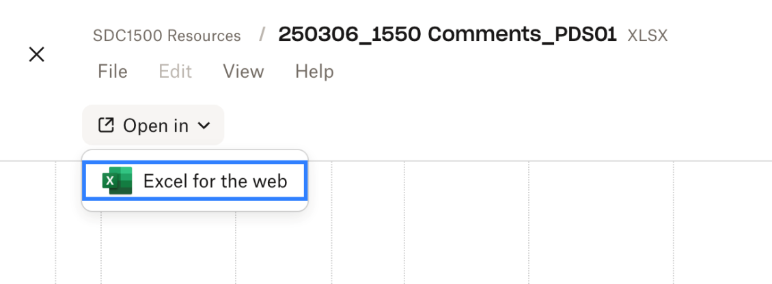
2. Draft responses for rejections will be on the spreadsheet starting next week. We won’t review during meetings but leave comments if you have suggestions or concerns.   
   We will vote as a group on all responses at the end of the process prior to sending them to the SDC.
3. We will select a range of comments to address at each meeting in advance so you can prepare in advance.  
   This week, we will try to move through all of the acceptances.
4. Next week, we will move to “accept in principle.” We will add draft text to Column M in advance of the meeting, so we have a basis for discussion. Please review in advance and, if possible, leave comments in Column M.
5. We will identify in advance the comments we intend to address at each meeting.