**Draft PDS-01 Addendum 85**

**Temporarily Converted Garage**

***Modify MINHERS Chapter 3 section 303.1 as follows:***

**Exception 4: RESNET Home Energy Ratings shall be calculated using the modifications of Standards ANSI/RESNET/ICC 301~~-2019~~ established by MINHERS addenda:**

* [**Addendum 66**](https://www.resnet.us/wp-content/uploads/FS_Adndm66f_v3.pdf)**, ~~and~~ CO2e Index**
* [**Addendum 79**](https://www.resnet.us/wp-content/uploads/FS_Adndm79f_InformNoteCrctn.pdf)**~~.~~ , Table 5.1.2(1) Informative Note Correction**
* **Addendum 77, Integrated Heat Pump Water Heater (iHPWH)**
* **Addendum 82, Direct Expansion Heat Pump and Air Conditioner Modeling**
* **Addendum 85, Temporarily Converted Garage**

**Exception *x*:** RESNET Home Energy Ratings shall comply with the requirements of ANSI/RESNET/ICC 301 and its Addenda and ANSI/RESNET/ICC 380 and its Addenda except for the following modifications to address temporarily converted garages:

* Modify ANSI / RESNET / ICC 301 and ANSI / RESNET / ICC 380, add the following definition for Temporarily Converted Garage:

**“Temporarily Converted Garage x** –A space attached to, or part of, a Dwelling that meets all of the following conditions:

* 1. The Dwelling is new construction;
  2. The floor area of the space does not exceed 1,000 square feet;
  3. The space is thermally isolated from the rest of the Dwelling as indicated by the presence of insulation in any shared building envelope components;
  4. If direct openings are present between the space and the rest of the Dwelling, they are contained in the wall plane itself, not within ceiling or floor cavities, and do not exceed a total of 50 square feet;
  5. Any ducts serving the Dwelling that are in the space, or that penetrate the walls or ceilings separating the Dwelling from the space, do not have registers or other openings into the space;
  6. The space has a garage door or, if not, then at least one side of the foundation is at-grade with an above-grade framed opening measuring no less than 8 ft wide and 7 ft high to accommodate the future installation of a garage door. The opening is permitted to be concealed at the time of the rating, for example with drywall and exterior finishes.

Such spaces shall be treated exactly like a garage wherever a garage is referenced in this standard, unless otherwise noted.

*x. (Informative Note) Such a space would typically serve as a garage but has been converted to a sales center, construction office, or other use during the construction and sales process.”*

* Modify ANSI / RESNET / ICC 301, edit the footnote associated with Section 4.5.2 Standard Features as follows:
  + “98. (Informative Note) For example, for a model home that has a Temporarily Converted Garage serving as ~~in which a garage has been converted into~~ a sales office, the Minimum Rated Features shall reflect the home with the Temporarily Converted Garage ~~sales office~~ because…”
* Modify ANSI / RESNET / ICC 301, add the following Rated Feature to Appendix B:

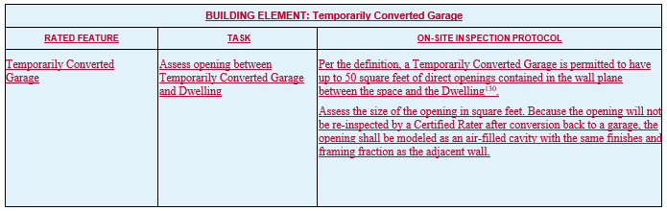

“130. (Informative Note): Such openings would typically serve as an entryway between the Dwelling and the space until the Temporarily Converted Garage (e.g., a sales center) is converted back to a garage, at which time the opening would be finished as an insulated garage wall.”

* Modify ANSI / RESNET / ICC 380, add new Section 4.2.3.1:
  + **“4.2.3.1.** Per the definition, a Temporarily Converted Garage is permitted to have direct openings in the wall plane between the space and the Dwelling not exceeding a total of 50 square feet. If direct openings are present, 140 CFM50 shall be added to the measured airflow, and the openings shall be temporarily sealed for the duration of the test.”