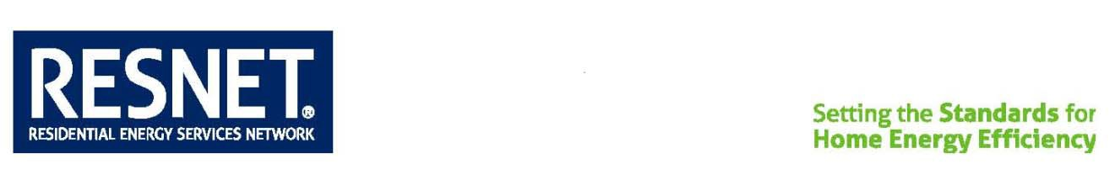

## Standard Revision

Date Approved: March 21, 2019 MINHERS Addendum 41i

Date Effective: March 21, 2019

Proponent: Standard Development Committee 300

Organization: RESNET

## Justification:

The purpose of this addendum is to provide a temporary exemption from infiltration testing for homes in Puerto Rico and the US Virgin Islands.

HUD is tying recovery funds on these islands to efficiency programs, which creates an opportunity for RESNET to increase HERS ratings on these islands. However, because the rating infrastructure on the islands is in its infancy, blower doors are an expensive investment.

Furthermore, the cost of testing each home outweighs its value in many cases. Due to the extremely temperate weather in these locations, the infiltration rate has a negligible impact on the HERS rating. For example, in one home in Puerto Rico, the HERS impact of increasing infiltration from 3 to 10 ACH50 was 1 HERS point. To overcome this obstacle, we propose adding an exception to the MINHERS standard allowing Raters doing HERS ratings in Puerto Rico and the US Virgin Islands to use a very high default infiltration rate of 10 ACH50 in lieu of testing for a limited period of time.

**Note:**

This Addendum is written to conform to the language of Addendum 42 that updates the section 303.1 reference to the 2019 edition of Standard ANSI/RESNET/ICC 301. Addendum 42 was recently approved and its effective date is July 1, 2019. Between the March 21, 2019 approval date of this “interim” Addendum 41i and July 1, 2019 the exception it adds will be designated “Exception 4” to section 303.1 and section 303.1 refers to the 2014 edition of Standard ANSI/RESNET/ICC 301.

***Modifications to the chapter are given below in underline/strikeout format***

# Chapter Three RESNET Standards

303 Technical Requirements

303.1 Applicable Standards

All RESNET Home Energy Ratings conducted in accordance with this Standard shall comply with the provisions of ANSI/RESNET/ICC 301, “Standard for the Calculation and Labeling of the Energy Performance of Dwelling and Sleeping Units using an Energy Rating Index.”

Exception 1: RESNET Home Energy Ratings conducted in Puerto Rico and the US Virgin Islands shall comply with the provisions of ANSI/RESNET/ICC 301, except that Ratings of homes with a permit date prior to January 1, 2022 are permitted to use a default infiltration rate of 10 ACH50 in lieu of conducting an airtightness test in accordance with Standard ANSI/RESNET/ICC 380.